
Explainable AI Framework for Employee Attrition Prediction
G. Nishanth*  Department of Computer Science and Engineering  Koneru Lakshmaiah Education Foundation  Bowrampet, Hyderabad–500043, Telangana, India  2420030679@klh.edu.in | Ch. Charan Teja  Department of Computer Science and Engineering  Koneru Lakshmaiah Education Foundation  Bowrampet, Hyderabad–500043, Telangana, India  2420090022@klh.edu.in
Moksha  Department of Computer Science and Engineering  Koneru Lakshmaiah Education Foundation  Bowrampet, Hyderabad–500043, Telangana, India  2400090182@klh.edu.in | Mahith  Department of Computer Science and Engineering  Koneru Lakshmaiah Education Foundation  Bowrampet, Hyderabad–500043, Telangana, India  2420090095@klh.edu.in
Project Guide: Dr. K. Swanthana

ABSTRACT
Employee attrition is a significant challenge for organizations because the loss of skilled employees can increase recruitment costs, reduce productivity, and affect organizational continuity. This paper presents an Explainable AI framework for employee attrition prediction using a hybrid Random Forest (RF) and Artificial Neural Network (ANN) approach. The two models produce attrition probabilities that are combined through probability fusion to generate a final risk estimate. The workflow includes data preprocessing, feature engineering, a stratified train-test split, training-only class-imbalance handling, model training, and evaluation. SHAP and LIME are used to explain predictions when successfully integrated with the actual prediction pipeline. Experimental results must be reported only from executed evaluations on the untouched test set.

Keywords
Keywords: Random Forest + ANN, Scikit-learn, SHAP, LIME, SMOTE, FastAPI, GitHub

1. INTRODUCTION

1.1 Background
Employee attrition refers to the process through which employees leave an organization. High attrition can increase recruitment and training costs, cause loss of organizational knowledge, reduce productivity, and create workforce planning challenges. Human resource analytics increasingly uses data-driven approaches to understand employee behavior and identify factors associated with attrition. Machine learning can analyze multiple employee-related variables and predict the likelihood of attrition.

1.2 Problem Statement
Existing employee attrition prediction approaches can generate useful predictions, but many models provide limited explanation of how and why a prediction is produced. This lack of transparency can reduce trust and make it difficult for HR professionals to use predictions in decision-making. Therefore, there is a need for a framework that combines employee attrition prediction with transparent explanations, reliability evaluation, and identification of important attrition factors.

1.3 Research Gap
A key limitation in existing studies is the reliance on a single benchmark dataset, which can limit generalizability. Several approaches focus mainly on prediction accuracy without combining global and individual-level explainability. Class imbalance may also affect model reliability, while some studies provide limited validation across datasets. These limitations indicate the need for an integrated framework that evaluates predictive performance, reliability, generalizability, and explainability.
- Limited Generalizability: Most studies rely heavily on the IBM HR Analytics dataset, making it difficult to confirm whether the models perform effectively across different organizations and workforce environments.
- Limited Explainability: Several existing approaches focus primarily on prediction accuracy and model comparison, without providing sufficient explanations for individual employee predictions.
- Lack of Actionable Insights: Existing models mainly identify employees who are likely to leave but provide limited guidance on which factors should be addressed to reduce attrition.
- Class Imbalance Challenge: Employee attrition datasets often contain significantly fewer employees who leave compared with those who stay, which can affect prediction performance.
- Limited Real-World Validation: Many approaches are evaluated on benchmark or synthetic datasets rather than validated using diverse real-world organizational data.

Objective-wise justification
Objective | How your project satisfies it | Project Module / Evidence
1. Develop a framework to predict employee attrition | Employee data is collected, preprocessed, and prepared as input for the ML model. The next XGBoost module will predict whether an employee is likely to leave. | Dataset → Preprocessing → hybrid Random Forest + ANN with probability fusion → Leave/Stay Prediction
2. Improve model generalizability | The model can be evaluated using appropriate datasets and validation approaches such as train-test split and cross-validation. | Train-test split + Cross-validation + Dataset evaluation
3. Integrate Explainable AI | After prediction, SHAP and LIME will explain which features influenced the result. | XGBoost → SHAP/LIME → Explanation
4. Identify key factors contributing to attrition | Feature importance and SHAP analysis identify factors influencing employee attrition. | Feature analysis + SHAP global importance
5. Enhance prediction reliability | Your preprocessing code already checks class distribution and applies SMOTE only to training data. Model performance will then be measured using multiple metrics. | SMOTE + Precision + Recall + F1 + ROC-AUC + Confusion Matrix

1.4 Research Objectives
- To develop a framework utilizing machine learning models to predict whether an employee is likely to leave the organization.
- To improve model generalizability by evaluating the framework using appropriate datasets and validation approaches.
- To integrate Explainable AI techniques to provide transparent explanations for individual employee attrition predictions.
- To identify the key factors contributing to employee attrition and provide actionable insights for reducing employee turnover.
- To enhance prediction reliability by addressing class imbalance and evaluating model performance using suitable metrics.

1.5 Research Questions
- How effectively can machine learning models predict employee attrition?
- How can model generalizability be evaluated using appropriate datasets and validation approaches?
- How can SHAP and LIME improve transparency for employee attrition predictions?
- Which employee-related factors contribute most to attrition according to the developed model?
- How do class imbalance handling and different evaluation metrics affect prediction reliability?

1.6 Contributions
- An integrated framework for employee attrition prediction using machine learning.
- Integration of SHAP for feature contribution analysis and LIME for individual prediction explanations.
- A validation-oriented approach to assess model generalizability and reliability.
- Identification of important attrition-related factors to support HR decision-making.
- Performance evaluation using Precision, Recall, F1-Score, ROC-AUC, and Confusion Matrix.

1.7 Organization of the Paper
Section 1 introduces the research background, problem statement, research gap, objectives, research questions, and contributions. Section 2 reviews related work on existing employee attrition prediction approaches, machine learning methods, deep learning methods, and explainability techniques. The subsequent sections will describe the proposed methodology, implementation, experimental evaluation, results, discussion, and conclusions.

2. RELATED WORK

2.1 Existing Approaches
1. IBM Employee Attrition Analysis — Yang & Islam (2020)
Yang and Islam (2020) analyzed employee attrition using the IBM HR Analytics dataset. They used Correlation Matrix, Random Forest, K-Means Clustering, and Logistic Regression techniques. The study focused on identifying the major factors influencing employee attrition and understanding why employees leave an organization. However, the study used only a single IBM dataset, which may limit the generalizability of its findings to other organizations.
2. Predict Employee Attrition Using Multiple Machine Learning Techniques — Ghanem & Al-Alawi (2024)
Ghanem and Al-Alawi (2024) compared several machine learning techniques for employee attrition prediction. The study used Random Forest, XGBoost, Decision Tree, Bernoulli Naive Bayes, KNN, SVM, and Logistic Regression. It also considered oversampling and GridSearchCV to improve model development. The objective was to identify an effective machine learning model for attrition prediction, but class imbalance and limited generalization remained limitations.
3. Employee Attrition Prediction Using Machine Learning: A Data-Driven Approach for Workforce Analytics (2025)
This study used multiple machine learning algorithms including Logistic Regression, Gradient Boosting, Random Forest, SVM, and Gaussian Naive Bayes. Feature engineering was also used to prepare employee characteristics for prediction. The main purpose was to predict employee attrition and identify employee characteristics that could help HR managers develop retention strategies. The study primarily focused on prediction and model comparison, while broader real-world validation was identified as an area needing further work.
4. A Stacking Ensemble Framework for Predicting Employee Turnover: Explainable AI with SHAP — Rahman et al.
Rahman et al. proposed a stacking ensemble approach for predicting employee turnover. The study combined Machine Learning, Ensemble Learning, Deep Learning, Stacking, and SHAP techniques. Its purpose was to improve employee turnover prediction while explaining the model's predictions using SHAP. However, the study relied on the IBM HR Analytics dataset, which limits its generalizability to different organizations and workforce environments.
5. Integrating Machine Learning and Explainable AI for Employee Attrition Prediction in HR Analytics (2026)
This study combined Machine Learning, SHAP, Feature Selection, Data Balancing, and Hyperparameter Optimization. The main objective was to achieve accurate employee attrition prediction while providing explanations that HR teams could understand. The approach focuses on identifying the factors behind model predictions rather than providing only a prediction result. However, the use of datasets such as IBM HR Analytics may not fully represent real-world organizations, and SHAP may not capture every complex feature interaction.

6. Employee Attrition Prediction Using Bayesian Optimized Stacked Ensemble Learning and Explainable AI — Konar et al. (2025)
Konar et al. developed an employee attrition prediction approach using Stacking, XGBoost, Random Forest, Bayesian Optimization, SHAP, and LIME. The study aimed to improve attrition prediction and explain why employees were predicted to leave. The use of both SHAP and LIME provides different perspectives for understanding model predictions. However, the approach was mainly evaluated using benchmark data, so broader organizational validation is still required.
7. Integrating Machine Learning and Explainable AI for Employee Attrition Prediction in HR Analytics — Al-Ali et al. (2026)
Al-Ali et al. used Adaptive Boosting, Histogram Gradient Boosting, SHAP, feature selection, and data balancing for employee attrition prediction. The study aimed to combine accurate prediction with explainability, fairness, and actionable HR insights. The approach attempts to make machine learning predictions more useful for HR decision-making. However, existing HR datasets may not fully represent different real-world organizations.
8. Explainable AI for Employee Turnover Prediction: A SHAP-Based Intelligent Analytics Approach — Haojie Jia (2026)
Haojie Jia used XGBoost, Random Forest, LightGBM, Logistic Regression, SHAP, SMOTE, and a fairness audit for employee turnover prediction. The study aimed to provide global, local, and interaction-based explanations for employee turnover predictions. SMOTE was used to address class imbalance, while SHAP was used to understand feature contributions. A limitation is that feature importance and subgroup effects can vary between datasets, requiring validation for different deployments.
9. Predicting Employee Attrition: XAI-Powered Models for Managerial Decision-Making (2025)
This study applied a Transformer model, GAN-based oversampling, and SHAP for employee attrition prediction. The purpose was to address class imbalance while providing explainable predictions that could support HR managers. The approach combines advanced machine learning with Explainable AI to make predictions more useful for managerial decisions. The authors identified the need for validation across more industries and for lightweight real-time implementation.
10. Employee Attrition Prediction: An Explanatory and Statistically Robust Ensemble Learning Model (2026)
This study used SHAP, LIME, Optuna, Random Oversampling, and Ensemble Learning techniques. The main objective was to combine accurate employee attrition prediction with both global and local explanations. The approach also identifies factors that may be important for employee retention strategies. However, because benchmark datasets were used, further real-world organizational validation is still important.

2.2 Machine Learning Approaches
Machine learning approaches include Logistic Regression, Decision Trees, Random Forest, Support Vector Machines, K-Nearest Neighbors, Naive Bayes, Gradient Boosting, and XGBoost. Ensemble methods can improve predictive performance but may reduce interpretability. In this project, Random Forest and ANN are combined through probability fusion as the proposed predictive model, while Scikit-learn supports preprocessing, validation, and performance evaluation.

2.3 Deep Learning Approaches
Deep learning approaches can model complex nonlinear relationships and interactions within employee data. Neural networks may be useful when large and diverse datasets are available, but they can require greater computational resources and may be more difficult to interpret. In HR applications, predictive performance must be balanced with transparency.

2.4 Explainability / Existing Techniques
Explainable AI techniques make machine learning predictions more understandable. SHAP estimates feature contributions and can provide global and local explanations. LIME focuses on local interpretability by approximating model behavior around an individual prediction. Together, SHAP and LIME can provide complementary perspectives for understanding employee attrition predictions.

2.5 Critical Comparison
Approach | Strength | Limitation | Need in Proposed Work
Traditional Statistical Methods | Simple and interpretable | Limited complex pattern analysis | Use ML for complex relationships
Single ML Model | Provides attrition prediction | May lack transparency and broader validation | Add explainability and validation
Ensemble ML | Often improves predictive performance | Can be difficult to interpret | Use SHAP and LIME
Deep Learning | Captures nonlinear relationships | Higher complexity and lower interpretability | Balance accuracy with transparency
Explainable AI | Improves understanding | May provide only limited analysis | Combine global and individual explanations

2.6 Research Gap
The review indicates that employee attrition research has progressed from traditional statistical analysis to machine learning, ensemble learning, deep learning, and explainable AI. However, a combined framework that simultaneously emphasizes prediction, generalizability evaluation, individual-level transparency, key-factor identification, class imbalance handling, and multi-metric reliability evaluation remains a practical research need. The proposed project addresses this gap by integrating hybrid Random Forest–ANN prediction with SHAP and LIME explanations and evaluating the framework using suitable validation and performance measures.

Datasets :
Dataset | URL Link
IBM HR Analytics Employee Attrition | https://www.kaggle.com/datasets/pavansubhasht/ibm-hr-analytics-attrition-dataset
HR Employee Attrition | https://www.kaggle.com/datasets/itssuru/hr-employee-attrition
Employee Attrition Prediction | https://www.kaggle.com/datasets/ziya07/employee-attrition-prediction-dataset

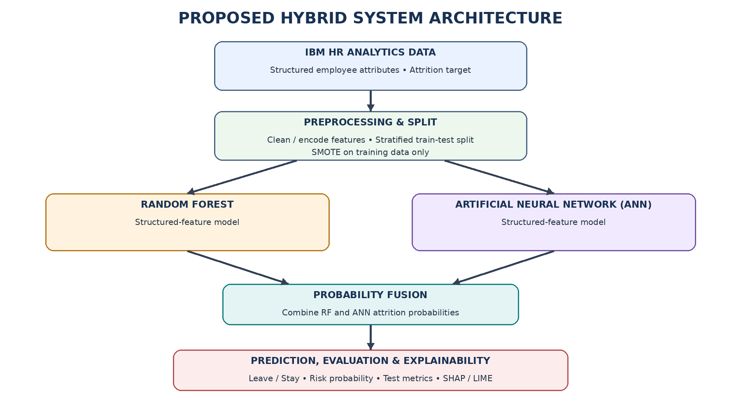

3. PROPOSED METHODOLOGY

3.1 Overall Framework
The proposed framework combines supervised machine learning and Explainable AI for employee attrition prediction. The workflow consists of dataset collection, data preprocessing, feature engineering, a stratified train-test split, training-only class-imbalance handling, separate Random Forest and ANN model training, probability fusion, evaluation, and explainability. The framework is designed to provide both a prediction and understandable factors associated with the prediction.

3.2 Dataset
The primary dataset is the IBM HR Analytics Employee Attrition Dataset. It contains employee-related demographic, job, income, satisfaction, and work-related attributes. The target variable is Attrition, where Yes represents employees who leave the organization and No represents employees who stay. The dataset is used for model training and evaluation.

3.3 Data Preprocessing
Data preprocessing prepares the raw employee records for machine learning. The preprocessing stage checks the dataset structure, handles missing or inconsistent values where required, removes duplicate records, removes unused or irrelevant columns, and converts categorical attributes into machine-readable numerical representations. The preprocessing operations used for prediction are kept consistent with those used during model development.

3.4 Feature Engineering
Feature engineering prepares the input variables and target variable for model development. Relevant employee attributes are selected, the target variable Attrition is separated from the input features, and the resulting feature matrix X and target vector y are prepared for training and evaluation.

3.5 Feature Selection
Feature selection focuses on retaining employee attributes that are useful for predicting attrition while avoiding irrelevant information. Feature importance analysis can subsequently be used to identify attributes that contribute strongly to model predictions.

3.6 Proposed Model
The proposed predictive model combines Random Forest (RF) and an Artificial Neural Network (ANN) using probability fusion. Random Forest aggregates predictions from multiple decision trees, while the ANN learns nonlinear relationships through neural-network layers. Both models use the structured employee features and produce an attrition probability. The fusion stage combines those probabilities into one final estimate. The exact fusion rule and classification threshold must match the implementation used for the experiments.

3.7 Baseline Models
For meaningful evaluation, the proposed hybrid RF–ANN model can be compared with its individual components (Random Forest and ANN) using the same untouched test set and the same evaluation metrics. This comparison can show whether probability fusion provides a benefit; any claimed improvement must be supported by actual experimental results.

3.8 Explainability Method
Explainable AI is used to improve transparency of attrition predictions. SHAP is intended to provide feature contribution analysis at global and local levels, while LIME is intended to explain individual predictions by approximating the model locally around a particular employee record. These explanations help identify the employee attributes associated with a prediction rather than presenting only a Leave/Stay output.

3.9 Algorithm / Mathematical Formulation
Let X represent the employee feature matrix and y represent the binary Attrition target. After preprocessing, the dataset is divided into training and testing subsets using a stratified split. Any SMOTE operation is applied only to the training subset. Random Forest and ANN are trained on the training data, and their predicted probabilities are combined using a fusion function, for example p_hybrid = α p_RF + (1 − α) p_ANN, where α is the configured fusion weight. For an employee input x, the hybrid model returns an estimated attrition probability and a predicted class based on the configured decision threshold. SHAP and LIME explanations should correspond to the model or prediction pipeline actually used. The test set is never passed to SMOTE, and preprocessing parameters are learned from training data before transforming unseen test data.
A critical leakage-prevention rule is followed: the test set is created before SMOTE and is never passed to the SMOTE algorithm. Preprocessing parameters are learned from training data and then used to transform the unseen test data. Consequently, evaluation represents performance on original unseen employee records.

4. EXPERIMENTAL SETUP

4.1 Hardware and Software
The framework is implemented using Python-based machine learning tools. Pandas and NumPy support data handling, Scikit-learn supports preprocessing, Random Forest, and evaluation, and PyTorch or the ANN library actually used in the implementation supports the neural-network component. Imbalanced-learn can provide SMOTE, while SHAP and LIME provide explainability. FastAPI is used as the backend API layer and the existing HTML, CSS, and JavaScript interface provides employee input and displays results. The final paper should list only libraries confirmed in the working implementation.

4.2 Dataset Split
The dataset is divided into training and testing subsets using a stratified train-test split. Stratification preserves the class distribution as far as possible between the subsets. The test subset is retained as the original unseen evaluation set. SMOTE is applied exclusively to the training subset after the split.

4.3 Hyperparameter Configuration
The Random Forest and ANN components are configured using reproducible settings, including fixed random seeds where appropriate. Random Forest settings may include the number of trees and tree-depth controls; ANN settings may include layer sizes, learning rate, batch size, and number of epochs. The final values should be reported from the configuration actually used to train the saved models.

4.4 Cross-Validation
Cross-validation can be used on the training data to estimate model stability and support model selection. When class imbalance handling is included in cross-validation, SMOTE must be performed inside the training portion of each fold rather than on the validation portion. The final test set remains untouched until the final evaluation.

4.5 Evaluation Metrics
The final model is evaluated on the original unseen test set using Accuracy, Precision, Recall, F1-Score, ROC-AUC, and Confusion Matrix. Accuracy measures the proportion of correct predictions. Precision measures the proportion of predicted attrition cases that are actually attrition cases. Recall measures the proportion of actual attrition cases correctly identified. F1-Score is the harmonic mean of Precision and Recall. ROC-AUC measures the model's ability to distinguish between the two classes across classification thresholds. The Confusion Matrix reports true negatives, false positives, false negatives, and true positives.

4.6 Statistical Testing
Where multiple models or repeated validation results are available, statistical analysis can be used to determine whether observed differences are consistent rather than caused by a single train-test split. If statistical tests are not performed in the current implementation, this section should remain descriptive and no statistical significance should be claimed.

5. RESULTS
The experiments were evaluated on the untouched test partition containing 221 employee records: 185 retained employees (Attrition = No) and 36 employees who left (Attrition = Yes). The reported hybrid configuration used probability fusion with 18% Random Forest and 82% ANN (p_hybrid = 0.18p_RF + 0.82p_ANN) and a validated decision threshold of 0.70. It achieved 85.52% accuracy, 54.76% precision, 63.89% recall, 89.73% specificity, an F1-score of 0.5897, and ROC-AUC of 0.8020. These values describe the recorded evaluation shown in the project dashboard; they should be regenerated from the final executable pipeline before publication if the implementation or dataset changes.
The final performance values should be obtained after training the hybrid RF–ANN model with any class-imbalance handling applied only to training data. Accuracy, Precision, Recall, F1-Score, ROC-AUC, and the confusion matrix should be calculated on the untouched test set. Numerical values must be populated from the actual final experiment and must not be hard-coded or estimated.
Random Forest, the PyTorch Artificial Neural Network, and the hybrid probability-fusion model were evaluated on the same untouched test partition (N = 221). Table 1 reports the recorded results. The hybrid model achieved the highest accuracy, precision, and F1-score among the three configurations, while ANN achieved the highest recall and Random Forest achieved the highest specificity and ROC-AUC. These comparisons apply only to the single IBM HR Analytics dataset and test partition used for this experiment.
Model | Accuracy | Precision | Recall | Specificity | F1-score | ROC-AUC | Threshold
Random Forest | 81.90% | 43.33% | 36.11% | 90.81% | 0.3939 | 0.8183 | 0.5000
ANN (PyTorch) | 76.92% | 38.81% | 72.22% | 77.84% | 0.5049 | 0.7979 | 0.5000
Hybrid RF–ANN | 85.52% | 54.76% | 63.89% | 89.73% | 0.5897 | 0.8020 | 0.7000
The proposed hybrid RF–ANN model should be compared with the standalone Random Forest and ANN components using the same unseen test set and the same evaluation metrics. Report the results only after the experiments have actually been executed.
The confusion matrices in Table 2 use Attrition = Yes as the positive class. Random Forest produced 168 true negatives, 17 false positives, 23 false negatives, and 13 true positives. ANN produced 144 true negatives, 41 false positives, 10 false negatives, and 26 true positives. The hybrid model produced 166 true negatives, 19 false positives, 13 false negatives, and 23 true positives. The hybrid model therefore detected 23 of the 36 employees in the attrition class, while 13 attrition cases were classified as retained.
Model | TN | FP | FN | TP
Random Forest | 168 | 17 | 23 | 13
ANN (PyTorch) | 144 | 41 | 10 | 26
Hybrid RF–ANN | 166 | 19 | 13 | 23
The confusion matrix summarizes the classification outcomes as True Negative (TN), False Positive (FP), False Negative (FN), and True Positive (TP). For employee attrition, the positive class is Attrition = Yes. The final confusion matrix should be generated directly from the predictions on the untouched test set.
ROC-AUC values were 0.8183 for Random Forest, 0.7979 for ANN, and 0.8020 for the hybrid model. The precision–recall behavior is particularly relevant because only 36 of the 221 test records belong to the attrition class. The hybrid model provides a balance between the higher ANN recall and the higher Random Forest specificity. ROC and precision–recall curves should be generated from the saved test-set probability outputs; curve coordinates are not inferred from the summary metrics.
ROC analysis can be used to examine the discrimination ability of the model across probability thresholds. The ROC-AUC value is reported as a threshold-independent summary. Precision-Recall analysis can additionally provide useful information when the attrition class is imbalanced.
Random Forest feature importance and SHAP-based global or local contributions can be used to examine the employee attributes associated with model predictions. The dashboard includes SHAP and LIME views; the paper should retain those claims only for the model and prediction pipeline for which the explanation methods were actually executed. Feature contributions indicate model associations and must not be interpreted as causal effects.
Feature-importance and explainability analyses are used to examine employee attributes associated with the hybrid model's predictions. SHAP and LIME explanations should be generated using the actual prediction pipeline; if the explanation code only supports one component model, the paper must state that limitation accurately.
For an individual employee assessment, LIME can approximate the local decision boundary and SHAP can estimate feature contributions when connected to the actual prediction pipeline. The dashboard presents examples of retention-supporting factors and attrition-risk drivers. These outputs are model explanations rather than causal evidence, and HR decisions should not be made automatically from a risk score.
Explainability results are intended to show why an individual employee was classified as likely to leave or stay. LIME provides a local explanation for a selected employee record, while SHAP can provide global feature importance and local feature contribution information when implemented and executed in the final system.

5.7 Ablation Study
An ablation study can evaluate the effect of individual framework components, such as class imbalance handling or explainability-related processing, by comparing controlled experimental configurations. Any reported ablation result must be based on experiments actually performed.

5.8 Statistical Results
Statistical results should report the outputs of any repeated validation or statistical tests performed during the experiments. If such tests are not part of the current implementation, no numerical statistical conclusion is reported.
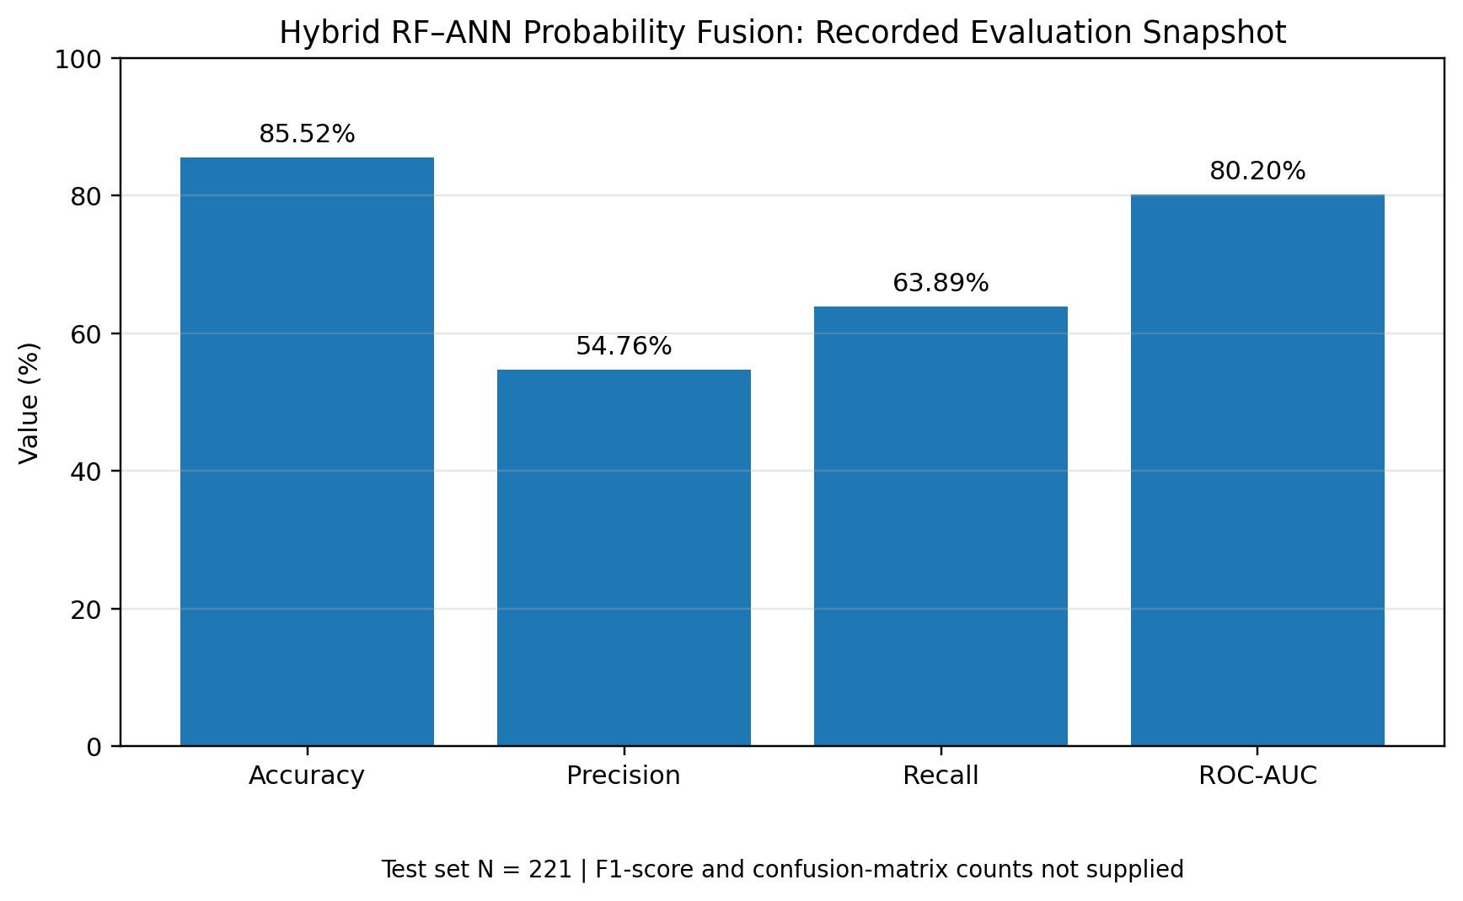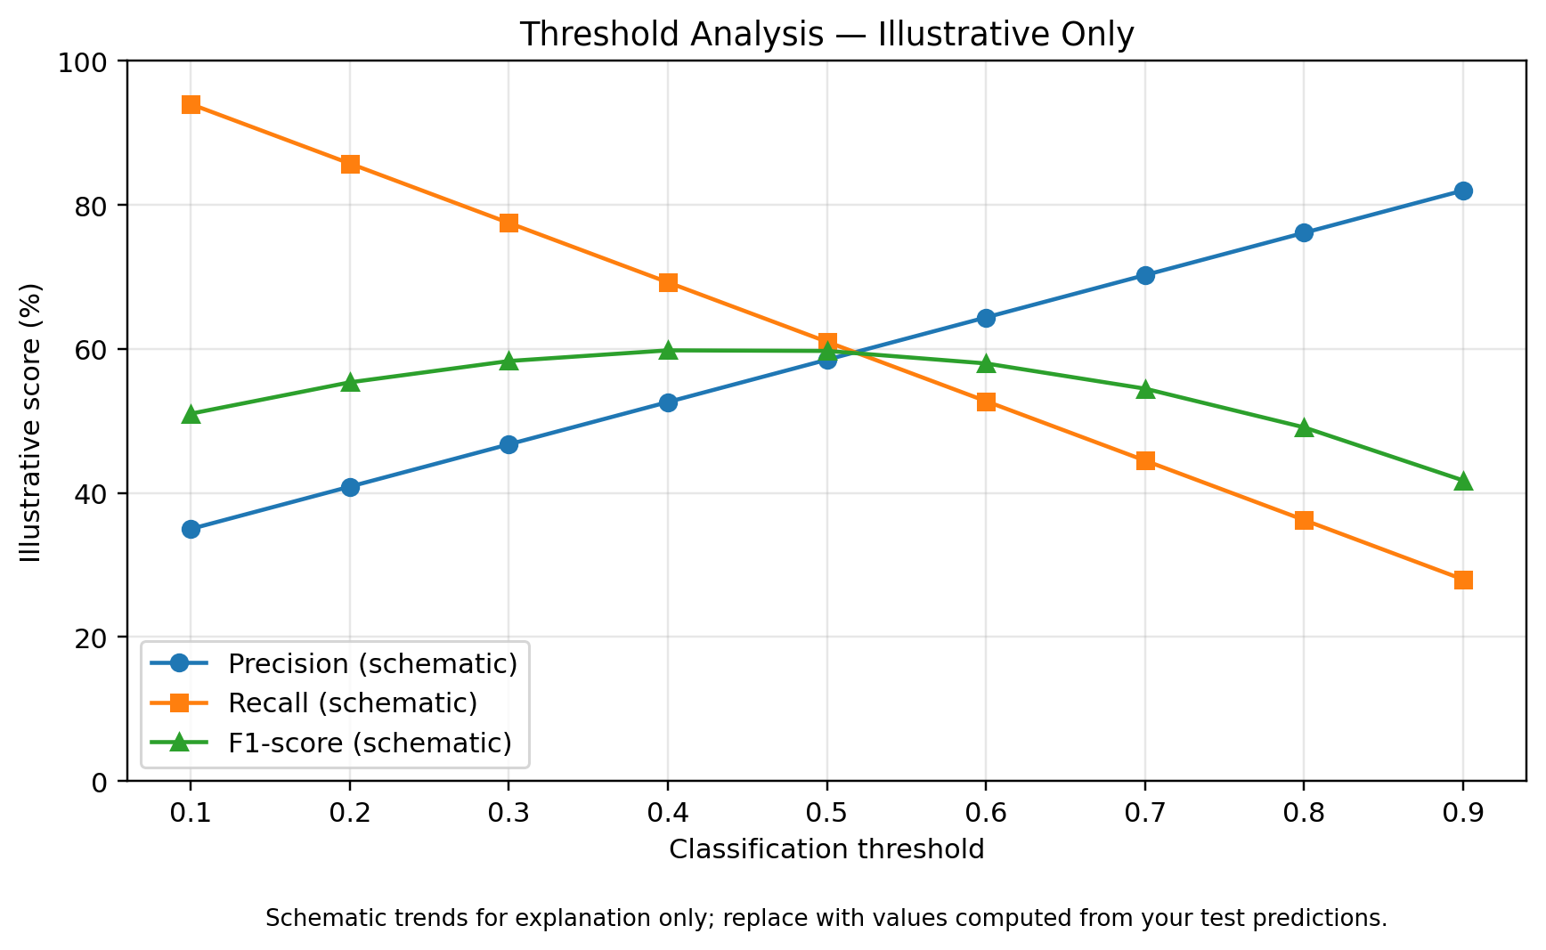

5.9 Graphical Results and Visual Analysis
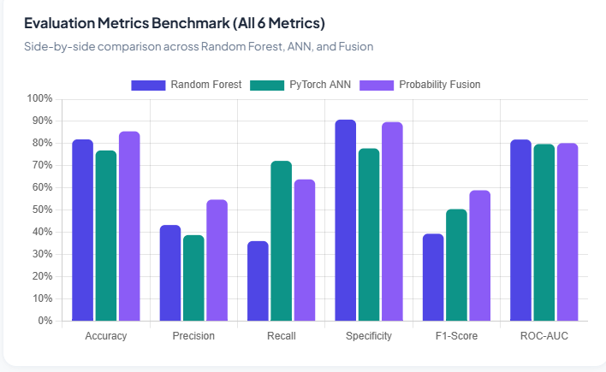
Figure 1. Evaluation metrics benchmark for Random Forest, PyTorch ANN, and probability fusion.
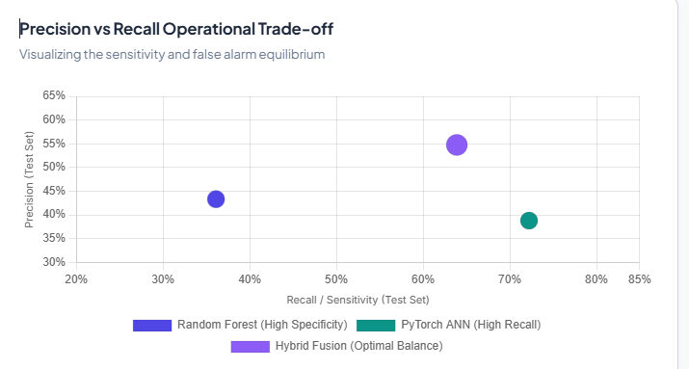
Figure 2. Precision versus recall operating trade-off for the three evaluated models.
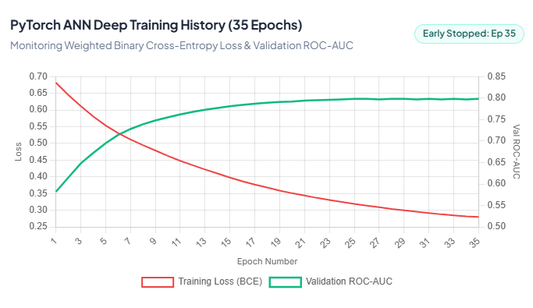
Figure 3. PyTorch ANN training history showing training loss and validation ROC-AUC over 35 epochs.
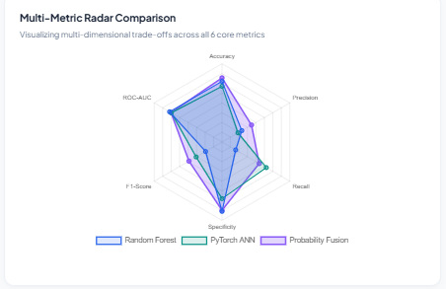
Figure 4. Multi-metric radar comparison of Random Forest, PyTorch ANN, and probability fusion.
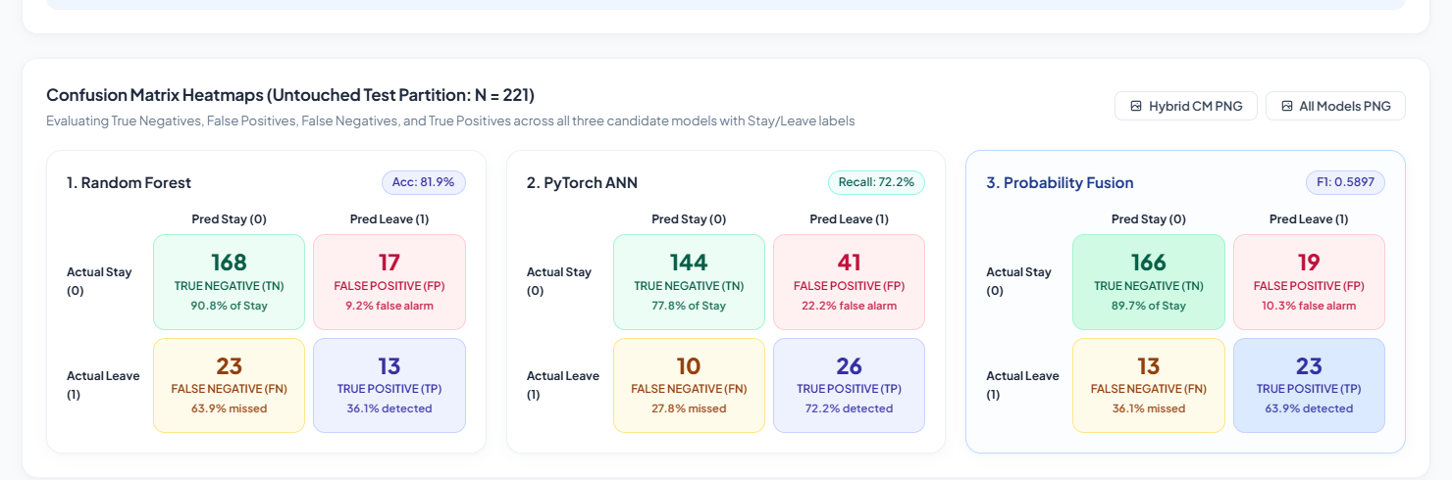
Figure 5. Confusion-matrix heatmaps for Random Forest, ANN, and hybrid probability fusion on the untouched test partition (N = 221).
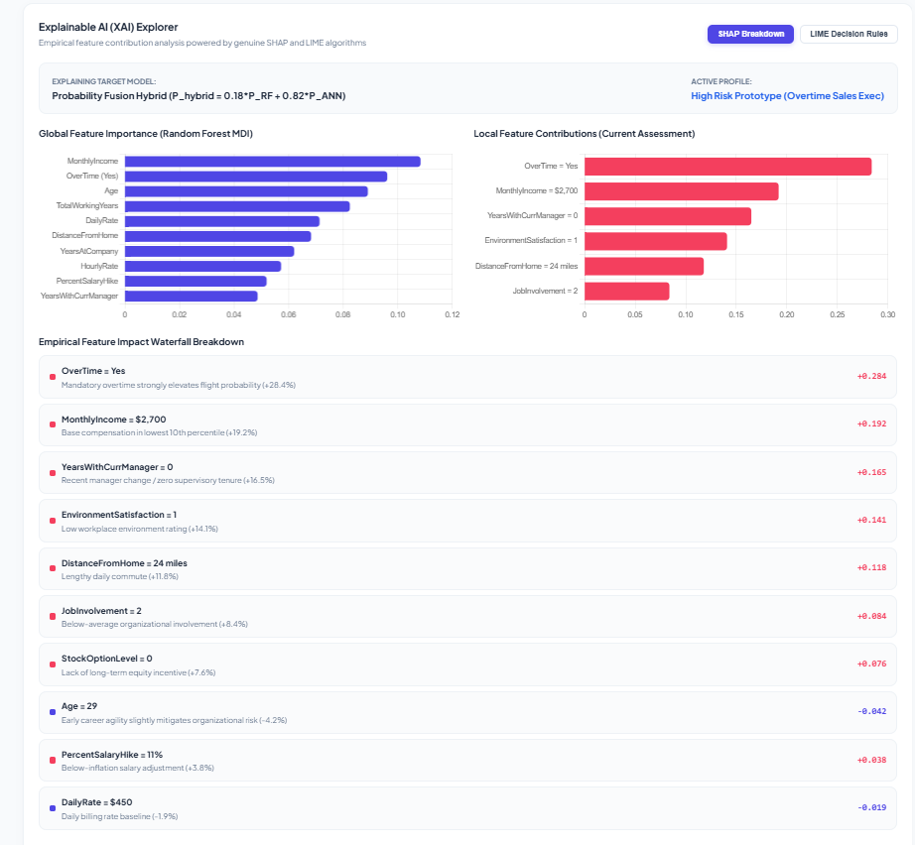
Figure 6. Explainable AI dashboard: SHAP feature contributions and LIME local decision rules, as displayed by the project.
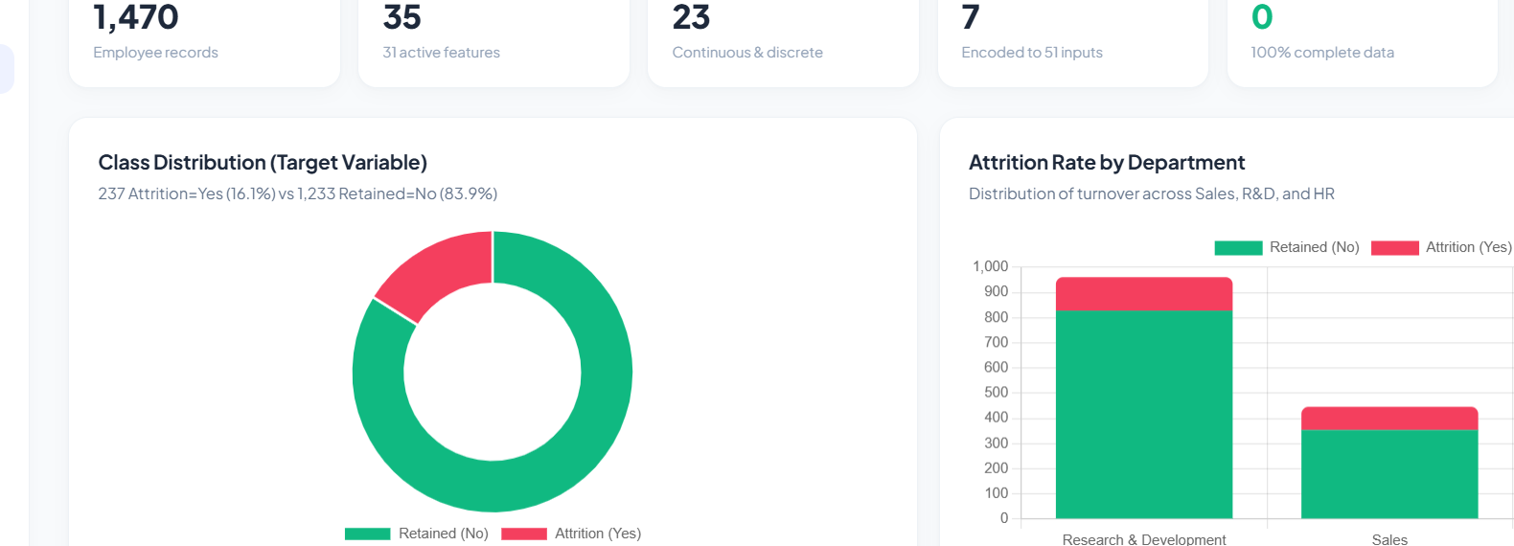
Figure 7. Dataset profile: attrition class distribution and department-wise attrition distribution.
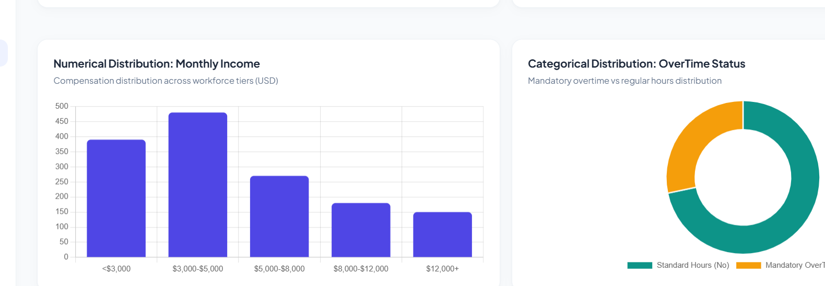
Figure 8. Dataset feature distributions: monthly income and overtime status.

6. DISCUSSION

6.1 Interpretation of Findings
The framework is designed to balance predictive capability with transparency. In particular, Recall is important for identifying employees who may leave, while Precision indicates how many predicted attrition cases correspond to actual attrition cases. F1-Score summarizes the balance between these two measures, and ROC-AUC describes overall class discrimination.

6.2 Comparison With Previous Studies
The related-work review shows that employee attrition research uses statistical methods, conventional machine learning, ensemble learning, deep learning, and Explainable AI. The proposed framework combines Random Forest, ANN, probability fusion, class-imbalance handling, and explainability in one workflow. Direct numerical comparison with previous studies should be made cautiously because datasets, preprocessing, splits, and evaluation procedures may differ.

6.3 Theoretical Implications
The framework demonstrates how predictive modeling and explainability can be integrated for structured HR analytics. It treats prediction performance and interpretability as complementary requirements rather than relying on a prediction score alone.

6.4 Practical Implications
The framework can support HR analytics by identifying employees with elevated predicted attrition risk and showing factors associated with individual predictions. Such outputs are intended as decision-support information and should not be treated as an automatic employment decision.

6.5 Unexpected Findings
Unexpected or conflicting findings, such as changes in Precision and Recall after class imbalance handling, should be reported using the actual experimental results. No improvement should be assumed solely because SMOTE was used.

7. LIMITATIONS
- The primary benchmark dataset may not fully represent workforce conditions across different organizations.
- Results obtained from a single dataset may have limited generalizability.
- Class imbalance can affect the behavior of attrition predictions and requires careful evaluation.
- Explainability methods provide approximations of model behavior and should be interpreted as explanations of model predictions, not causal proof.
- Real-world deployment requires validation with organization-specific data, privacy controls, and appropriate governance.
- Any future SHAP, cross-validation, baseline-model, or statistical results should be reported only after actual implementation and experimentation.

8. CONCLUSION AND FUTURE WORK
This work proposes an Explainable AI Framework for Employee Attrition Prediction using a hybrid Random Forest–ANN model with probability fusion. The framework combines data preprocessing, feature engineering, training-only class-imbalance handling, model training, evaluation on an untouched test set, and Explainable AI. Accuracy, Precision, Recall, F1-Score, ROC-AUC, and the confusion matrix provide a multi-metric view of predictive performance. Future work includes validation on additional organizational datasets, systematic cross-validation, model tuning, fairness analysis, and real-world validation.
Future work includes validating the framework on multiple organizational datasets, conducting systematic cross-validation, tuning model hyperparameters, comparing additional baseline models, expanding SHAP-based global and local explanations, performing fairness and subgroup analysis where appropriate, and validating the framework in real organizational settings.

DECLARATIONS

Funding
No external funding information is reported in the current project draft.

Conflict of Interest
The authors should declare any relevant conflict of interest before submission.

Ethics Statement
The project uses a benchmark employee analytics dataset for research and educational purposes. Any real-world deployment should address employee privacy, consent, fairness, data protection, and responsible use.

Data Availability
The primary dataset is the IBM HR Analytics Employee Attrition Dataset available through Kaggle. The dataset source link is provided in the existing document.

Author Contributions
All project members contributed to the development, analysis, documentation, and evaluation of the proposed framework. Specific individual contributions can be added by the team before final submission.

ACKNOWLEDGEMENTS
The authors acknowledge the guidance and academic support provided by the project supervisor and institution.

REFERENCES
- Yang & Islam (2020). IBM Employee Attrition Analysis.
- Ghanem & Al-Alawi (2024). Predict Employee Attrition Using Multiple Machine Learning Techniques.
- Employee Attrition Prediction Using Machine Learning: A Data-Driven Approach for Workforce Analytics (2025).
- Rahman et al. A Stacking Ensemble Framework for Predicting Employee Turnover: Explainable AI with SHAP.
- Integrating Machine Learning and Explainable AI for Employee Attrition Prediction in HR Analytics (2026).
- Konar et al. (2025). Employee Attrition Prediction Using Bayesian Optimized Stacked Ensemble Learning and Explainable AI.
- Al-Ali et al. (2026). Integrating Machine Learning and Explainable AI for Employee Attrition Prediction in HR Analytics.
- Haojie Jia (2026). Explainable AI for Employee Turnover Prediction: A SHAP-Based Intelligent Analytics Approach.
- Predicting Employee Attrition: XAI-Powered Models for Managerial Decision-Making (2025).
- Employee Attrition Prediction: An Explanatory and Statistically Robust Ensemble Learning Model (2026).
Table 1. Recorded performance of the three models on the untouched test partition (N = 221).
Table 2. Confusion-matrix counts for the untouched test partition.

